**Project 2: Framework to Test the Pedidosya.com Application in Different Environment.**

*pedidosya.com.ar automation test with Cucumber - TestNG - Selenium*

## Project description

This project looks to test essential functionality of the website from Argentina http://pedidosya.com.ar

**Scope**

We’ll create an automated process based on cucumber and Gherkin language that will test core functions: login, select the location and order food, making sure everything work as intended

## Tech stack

**Eclipse IDE 2020-12**

* Java 15.0.1 2020-10-20
* Selenium Webdriver 3.141.59
* Cucumber 6.10.2
* Maven compiler 3.8.1
* Maven surefire 2.2.22
* Extent reports
* JUnit 4.13.2
* TestNG 7.3.0
* Maven war plugin 3.3.1
* Git

## Test Architecture diagram / flow chart

**Phase 2 - Assessment**

**-SetupBrowser Class >** This class contains a Selenium grid connection and a regular webdriver setup.

**-Features and scenarios >** Simplified in 2 .features files with a total of 3 different scenarios

### -Assessment-login.feature

**-Feature: Login page feature**

**Scenario: Login**

Given User launches Chrome browser

When User opens URL "https://pedidosya.com.ar"

And Click Login button

And User enters user as "damianpereira.mdq@gmail.com" and password as "Pereiradamian1!"  
 Then The page title should be "Delivery Online - Elegí, Pedí y Ya | PedidosYa"

And The page shows the name "Damian"

**Scenario: Set location**

Given User has logged in successfully

When User selects the city "Mar del Plata"

And User enter the address "Tripulantes del Fournier 3474"

And User confirms the entered location

Then The page updated title should be "Delivery para Tripulantes del Fournier 3474, Mar del Plata | Ped� Online con PedidosYa"

**-Assessment-orderfoodandcheckout.feature**

# To simplify the process well add the rest of the steps in one Scenario

**Scenario: Order food and checkout**

Given User selects "Las Palmeras" restaurant

When User selects the option "Rabas"

And User confirms the selection

And User selects "Continuar"

Then It should load the checkout page

And The checkout page title should be "Checkout"

***Important note: this web application has a specific range of time when it’s open. If it’s not, we’ll not be able to order food and test it properly***

## 

## Packages and functionality

**Extent report config**

**src/main/resources**

extent.properties

extent-config.xml

**Listeners**

**com.pedidosya.listeners**

Logger.java

**Hooks**

**Included in the StepsDefinitions Class**

**Pages**

**com.pedidosya.pages**

LoginPage.java

OrderAndCheckoutPage.java

**Runner**

**Com.pedidosya.runner**

testRunner.java

**Step Definitions**

**Com.pedidosya.stepDefinitions**

StepDefinitions.java

**Browser Factory**

**Com.pedidosya.utils**

SetupBrowser.java

**Cucumber Features**

Assessment-login.feature

assessment-orderandcheckout.feature

## Project GIT Repositories

1. Link: <https://github.com/damianpereira-mdq/Project2-Assessment.git>  
  
GIThub screenshot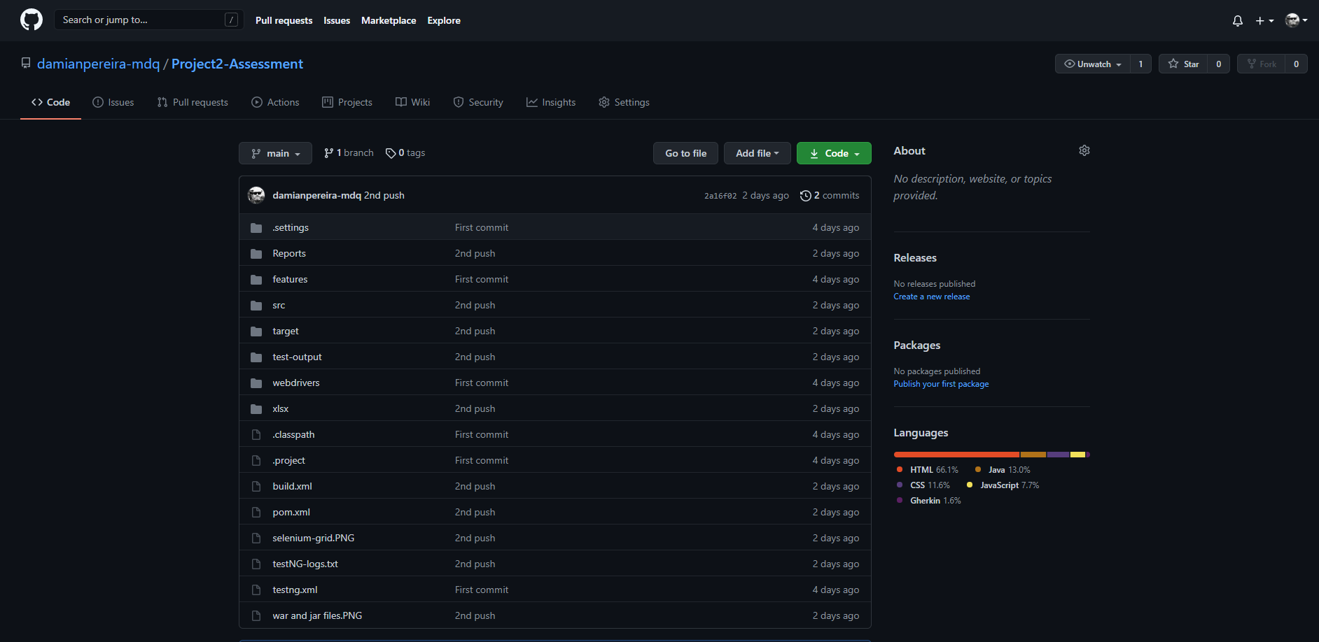

## 

## How to run project

1- Clone the project from GIThub

<https://github.com/damianpereira-mdq/Project2-Assessment.git>

2- Run the file testng.xml as TestNG Suite

## Directory Structure - **Maven Project**

## Source code files

## Test Output

